A MINOR PROJECT REPORT
As partial requirement for the degree of
Bachelor Of Computer Application
Using Data Analytics using Python
ON

GRADUATE ADMISSION PREDICTION SYSTEM

SUBMITTED BY : University Exam No.

Pathan Shahil Sarfaraz 1504
Malek Mubin Yasin 1470

UNDER GUIDANCE OF
Dr. Darshna Rajput

COMPUTER SCIENCE DEPARTMENT,
Dolat-Usha Institute Of Applied Sciences And Dhiru-Sarla Institute of Management & Commerce, Valsad

Affiliated with
Veer Narmad South Gujarat University, Surat

* 2025-2026 *



Index

Sr. No. | Contents | Page No.
1  1.1  1.2  1.3 | Introduction  Project Overview  Problem Statement  Objectives | 4
2  2.1  2.2 | Dataset Description  Dataset  Dataset Attributes | 7
3 | Tools and Technologies Used  Python, Flask, Pandas, NumPy, Matplotlib, Seaborn, Etc. | 8
4 | Exploratory Data Analysis (EDA) | 9
5  5.1  5.2 | Machine Learning Models  Prediction (Regression)  Prediction (Classification) | 10
6 | Web Dashboard Implementation | 11
7 | Results and Discussion | 63
8 | Conclusion and Future Scope | 71
9 | References | 73

INTRODUCTION

Graduate Admission Prediction System

- THE GRADUATE ADMISSION PREDICTION SYSTEM IS A DATA ANALYTICS PROJECT THAT ANALYZES STUDENTS’ ACADEMIC RECORDS SUCH AS GRE SCORE, TOEFL SCORE, CGPA, AND RESEARCH EXPERIENCE TO PREDICT THE CHANCES OF ADMISSION INTO GRADUATE PROGRAMS.

- THE SYSTEM USES MACHINE LEARNING ALGORITHMS TO PROVIDE AN ESTIMATED PROBABILITY OF ADMISSION.

PROBLEM STATEMENT

- STUDENTS APPLYING FOR GRADUATE PROGRAMS OFTEN DO NOT KNOW THEIR CHANCES OF ADMISSION BASED ON THEIR ACADEMIC PROFILE.

- THIS PROJECT AIMS TO ANALYZE ACADEMIC DATA AND BUILD A PREDICTIVE MODEL THAT ESTIMATES THE PROBABILITY OF ADMISSION.

OBJECTIVES

- TO ANALYZE GRADUATE ADMISSION DATASET.
- TO PERFORM EXPLORATORY DATA ANALYSIS.

- TO BUILD A REGRESSION MODEL FOR PREDICTING ADMISSION CHANCES.

- TO CLASSIFY ADMISSION PROBABILITY LEVELS.

- TO DEVELOP A WEB DASHBOARD FOR USER INTERACTION.

DATASET

- Dataset Overview

  - Dataset Name: Graduate Admission Dataset Number of Rows: 500 rows
Number of Columns: 9 columns

- Attributes
- GRE Score
- TOFEL Score
- University Rating
- SOP
- LOR
- CGPA
- Research
- Chance of Admit

- Variables

- Independent Variables (Features)
GRE Score,TOFEL Score,University Rating,SOP,LOR,CGPA,Research

- Dependent Variable (Target)
Chance Of Admit

TOOLS AND TECHNOLOGIES

- The following tools and technologies were used in the project:

- Programming Language
- Python

- Libraries
- Pandas
- NumPy
- Matplotlib
- Seaborn
- Scikit-learn

- Framework
- Flask

- IDE
- VS Code

EXPLORATORY DATA ANALYSIS

- Exploratory Data Analysis was performed to understand the dataset and identify patterns.

- Data Cleaning
- Removed missing values
- Converted data types
- Cleaned column names

- Data Visualization
- Various charts were created to analyze relationships in the dataset:
- GRE vs Admission
- CGPA vs Admission
- Reserach vs Admission
- TOFEL vs Admission

- Pattern Identification :
- Students with higher CGPA and GRE scores tend to have higher chances of admission.

PREDICTION [ REGRESSION]

Objective: Student ke profile ke basis par Chance of Admit ki exact probability predict karna.
Models Used:
- Linear Regression
- Decision Tree Regressor
- Random Forest Regressor
Train-Test Split: 80% Training, 20% Testing
Evaluation Metrics: R² Score, Mean Squared Error (MSE), Mean Absolute Error (MAE)

PREDICTION (CLASSIFICATION)

Objective: Student ki admission chance ko High (1) ya Low (0) mein classify karna.
Target Definition: Agar Chance of Admit >= 0.75 → High (1), else Low (0)
Models Used:
- Logistic Regression
- Decision Tree Classifier
- Random Forest Classifier
Train-Test Split: 80% Training, 20% Testing
Evaluation Metrics: Accuracy Score, Confusion Matrix, Classification Report

WEB DASHBOARD

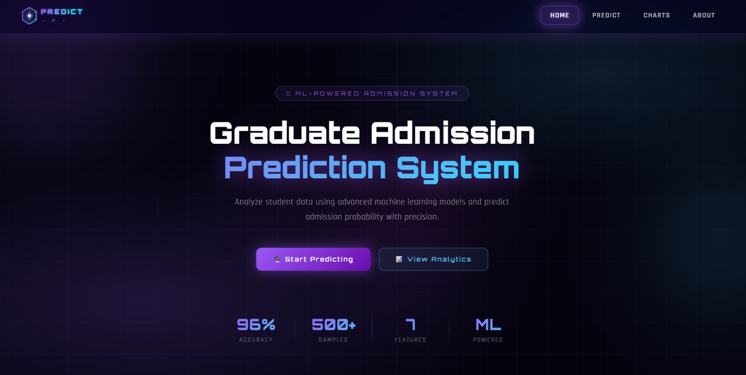

<!DOCTYPE html>
<html lang="en">
<head>
<meta charset="UTF-8" />
<meta name="viewport" content="width=device-width, initial-scale=1.0"/>
<title>Admission Prediction Dashboard</title>
<link href="https://fonts.googleapis.com/css2?family=Orbitron:wght@400;600;900&family=Rajdhani:wght@300;400;600&display=swap" rel="stylesheet"/>
<style>
:root {
--neon-purple: #9b59f5;
--neon-blue: #4fc3f7;
--neon-cyan: #00e5ff;
--neon-pink: #e040fb;
--bg-dark: #04040f;
--glass-bg: rgba(255,255,255,0.04);
--glass-border: rgba(155,89,245,0.25);
--glow-purple: 0 0 20px rgba(155,89,245,0.5), 0 0 60px rgba(155,89,245,0.2);
--glow-blue: 0 0 20px rgba(79,195,247,0.5), 0 0 60px rgba(79,195,247,0.2);
}

* { margin: 0; padding: 0; box-sizing: border-box; }

body {
font-family: 'Rajdhani', sans-serif;
background: var(--bg-dark);
color: white;
min-height: 100vh;
overflow-x: hidden;
}

/* ── ANIMATED BACKGROUND ── */
.bg-canvas {
position: fixed; inset: 0; z-index: 0;
background:
radial-gradient(ellipse 80% 60% at 20% 80%, rgba(155,89,245,0.18) 0%, transparent 60%),
radial-gradient(ellipse 60% 50% at 80% 20%, rgba(79,195,247,0.12) 0%, transparent 60%),
radial-gradient(ellipse 40% 40% at 50% 50%, rgba(224,64,251,0.06) 0%, transparent 70%),
#04040f;
}

/* Grid lines */
.bg-grid {
position: fixed; inset: 0; z-index: 0;
background-image:
linear-gradient(rgba(155,89,245,0.07) 1px, transparent 1px),
linear-gradient(90deg, rgba(155,89,245,0.07) 1px, transparent 1px);
background-size: 60px 60px;
animation: gridMove 20s linear infinite;
}
@keyframes gridMove {
0% { background-position: 0 0; }
100% { background-position: 60px 60px; }
}

/* Floating orbs */
.orb {
position: fixed; border-radius: 50%;
filter: blur(80px); z-index: 0; pointer-events: none;
animation: orbFloat 8s ease-in-out infinite;
}
.orb-1 {
width: 400px; height: 400px;
background: rgba(155,89,245,0.15);
top: -100px; left: -100px;
animation-delay: 0s;
}
.orb-2 {
width: 300px; height: 300px;
background: rgba(79,195,247,0.12);
bottom: 100px; right: -80px;
animation-delay: -3s;
}
.orb-3 {
width: 200px; height: 200px;
background: rgba(224,64,251,0.1);
top: 50%; left: 50%;
animation-delay: -6s;
}
@keyframes orbFloat {
0%, 100% { transform: translate(0,0) scale(1); }
33% { transform: translate(30px,-40px) scale(1.05); }
66% { transform: translate(-20px,20px) scale(0.95); }
}

/* ── NAVBAR (GLASSMORPHISM) ── */
.navbar {
position: fixed; top: 0; left: 0; right: 0; z-index: 100;
display: flex; align-items: center; justify-content: space-between;
padding: 0 50px;
height: 70px;
background: rgba(10, 5, 30, 0.55);
backdrop-filter: blur(20px) saturate(180%);
-webkit-backdrop-filter: blur(20px) saturate(180%);
border-bottom: 1px solid rgba(155,89,245,0.3);
box-shadow: 0 4px 30px rgba(155,89,245,0.15), inset 0 1px 0 rgba(255,255,255,0.06);
}

.nav-logo {
font-family: 'Orbitron', monospace;
font-weight: 900;
font-size: 18px;
letter-spacing: 3px;
background: linear-gradient(135deg, var(--neon-purple), var(--neon-blue));
-webkit-background-clip: text;
-webkit-text-fill-color: transparent;
background-clip: text;
filter: drop-shadow(0 0 8px rgba(155,89,245,0.8));
}

.nav-links {
display: flex; gap: 8px; align-items: center;
}
.nav-links a {
color: rgba(255,255,255,0.7);
text-decoration: none;
font-size: 14px;
font-weight: 600;
letter-spacing: 1.5px;
text-transform: uppercase;
padding: 8px 18px;
border-radius: 8px;
position: relative;
transition: all 0.3s ease;
border: 1px solid transparent;
}
.nav-links a:hover {
color: white;
background: rgba(155,89,245,0.15);
border-color: rgba(155,89,245,0.4);
box-shadow: 0 0 15px rgba(155,89,245,0.3);
text-shadow: 0 0 8px rgba(155,89,245,0.8);
}
.nav-links a.active {
color: white;
background: rgba(155,89,245,0.2);
border-color: rgba(155,89,245,0.5);
box-shadow: var(--glow-purple);
text-shadow: 0 0 10px var(--neon-purple);
}

.nav-btn {
padding: 9px 22px;
border-radius: 8px;
border: 1px solid var(--neon-purple);
background: rgba(155,89,245,0.2);
color: white;
font-family: 'Orbitron', monospace;
font-size: 11px;
font-weight: 600;
letter-spacing: 2px;
cursor: pointer;
transition: all 0.3s;
text-decoration: none;
box-shadow: 0 0 15px rgba(155,89,245,0.3);
}
.nav-btn:hover {
background: rgba(155,89,245,0.4);
box-shadow: var(--glow-purple);
transform: translateY(-1px);
}

/* ── MAIN CONTENT ── */
.main {
position: relative; z-index: 10;
padding-top: 70px;
min-height: 100vh;
}

/* ── HERO ── */
.hero {
text-align: center;
padding: 100px 40px 60px;
position: relative;
}

.hero-tag {
display: inline-block;
font-family: 'Orbitron', monospace;
font-size: 11px;
letter-spacing: 4px;
color: var(--neon-purple);
border: 1px solid rgba(155,89,245,0.4);
padding: 6px 20px;
border-radius: 20px;
background: rgba(155,89,245,0.08);
margin-bottom: 28px;
animation: fadeSlideDown 0.8s ease both;
}

.hero h1 {
font-family: 'Orbitron', monospace;
font-size: clamp(32px, 5vw, 58px);
font-weight: 900;
line-height: 1.15;
margin-bottom: 20px;
animation: fadeSlideDown 0.8s 0.1s ease both;
}
.hero h1 .line1 { display: block; color: white; }
.hero h1 .line2 {
display: block;
background: linear-gradient(135deg, var(--neon-purple) 0%, var(--neon-blue) 60%, var(--neon-cyan) 100%);
-webkit-background-clip: text;
-webkit-text-fill-color: transparent;
background-clip: text;
filter: drop-shadow(0 0 20px rgba(155,89,245,0.6));
}

.hero p {
font-size: 17px;
color: rgba(255,255,255,0.5);
max-width: 560px;
margin: 0 auto 44px;
line-height: 1.7;
letter-spacing: 0.5px;
animation: fadeSlideDown 0.8s 0.2s ease both;
}

.hero-btns {
display: flex; gap: 16px; justify-content: center;
flex-wrap: wrap;
animation: fadeSlideDown 0.8s 0.3s ease both;
}
.btn-primary {
padding: 14px 34px;
border: none;
border-radius: 10px;
background: linear-gradient(135deg, var(--neon-purple), #6a0dad);
color: white;
font-family: 'Orbitron', monospace;
font-size: 12px;
font-weight: 600;
letter-spacing: 2px;
cursor: pointer;
transition: all 0.3s;
box-shadow: 0 0 25px rgba(155,89,245,0.5);
text-decoration: none;
display: inline-flex; align-items: center; gap: 8px;
}
.btn-primary:hover {
transform: translateY(-3px);
box-shadow: 0 0 40px rgba(155,89,245,0.7), 0 10px 30px rgba(155,89,245,0.3);
}
.btn-secondary {
padding: 13px 32px;
border: 1px solid rgba(79,195,247,0.5);
border-radius: 10px;
background: rgba(79,195,247,0.08);
color: var(--neon-blue);
font-family: 'Orbitron', monospace;
font-size: 12px;
font-weight: 600;
letter-spacing: 2px;
cursor: pointer;
transition: all 0.3s;
text-decoration: none;
display: inline-flex; align-items: center; gap: 8px;
}
.btn-secondary:hover {
background: rgba(79,195,247,0.15);
box-shadow: var(--glow-blue);
transform: translateY(-3px);
}

/* ── STATS BAR ── */
.stats-bar {
display: flex; justify-content: center; gap: 0;
margin: 0 auto 80px;
max-width: 700px;
padding: 0 40px;
animation: fadeSlideDown 0.8s 0.4s ease both;
}
.stat-item {
flex: 1;
text-align: center;
padding: 24px 20px;
position: relative;
}
.stat-item:not(:last-child)::after {
content: '';
position: absolute; right: 0; top: 20%; bottom: 20%;
width: 1px;
background: linear-gradient(to bottom, transparent, rgba(155,89,245,0.4), transparent);
}
.stat-num {
font-family: 'Orbitron', monospace;
font-size: 30px;
font-weight: 900;
background: linear-gradient(135deg, var(--neon-purple), var(--neon-blue));
-webkit-background-clip: text;
-webkit-text-fill-color: transparent;
background-clip: text;
}
.stat-label {
font-size: 12px;
color: rgba(255,255,255,0.4);
letter-spacing: 2px;
text-transform: uppercase;
margin-top: 4px;
}

/* ── CARDS SECTION ── */
.section-label {
text-align: center;
font-family: 'Orbitron', monospace;
font-size: 11px;
letter-spacing: 5px;
color: rgba(155,89,245,0.7);
text-transform: uppercase;
margin-bottom: 12px;
}
.section-title {
text-align: center;
font-family: 'Orbitron', monospace;
font-size: clamp(22px, 3vw, 34px);
font-weight: 700;
margin-bottom: 50px;
color: white;
}
.section-title span {
background: linear-gradient(135deg, var(--neon-purple), var(--neon-cyan));
-webkit-background-clip: text;
-webkit-text-fill-color: transparent;
background-clip: text;
}

.cards-grid {
display: grid;
grid-template-columns: repeat(auto-fit, minmax(300px, 1fr));
gap: 24px;
max-width: 1100px;
margin: 0 auto;
padding: 0 40px 80px;
}

/* GLASS CARD */
.card {
background: rgba(255,255,255,0.03);
backdrop-filter: blur(20px);
-webkit-backdrop-filter: blur(20px);
border: 1px solid rgba(155,89,245,0.2);
border-radius: 20px;
padding: 34px 30px;
position: relative;
overflow: hidden;
transition: all 0.4s ease;
cursor: pointer;
text-decoration: none;
display: block;
color: white;
animation: cardFadeIn 0.8s ease both;
}
.card:nth-child(1) { animation-delay: 0.1s; }
.card:nth-child(2) { animation-delay: 0.2s; }
.card:nth-child(3) { animation-delay: 0.3s; }
.card:nth-child(4) { animation-delay: 0.4s; }

@keyframes cardFadeIn {
from { opacity: 0; transform: translateY(30px); }
to { opacity: 1; transform: translateY(0); }
}

/* Top glow line */
.card::before {
content: '';
position: absolute; top: 0; left: 20%; right: 20%; height: 1px;
background: linear-gradient(90deg, transparent, rgba(155,89,245,0.6), transparent);
transition: all 0.4s;
}
.card:hover::before {
left: 0; right: 0;
background: linear-gradient(90deg, transparent, var(--neon-purple), transparent);
box-shadow: 0 0 10px var(--neon-purple);
}

/* Hover glow */
.card::after {
content: '';
position: absolute; inset: 0;
border-radius: 20px;
opacity: 0;
transition: opacity 0.4s;
background: radial-gradient(ellipse at 50% 0%, rgba(155,89,245,0.12), transparent 70%);
}
.card:hover::after { opacity: 1; }

.card:hover {
border-color: rgba(155,89,245,0.5);
transform: translateY(-8px);
box-shadow: 0 20px 60px rgba(155,89,245,0.2), 0 0 0 1px rgba(155,89,245,0.1);
}

/* Blue variant */
.card.blue::before {
background: linear-gradient(90deg, transparent, rgba(79,195,247,0.6), transparent);
}
.card.blue:hover::before {
background: linear-gradient(90deg, transparent, var(--neon-blue), transparent);
box-shadow: 0 0 10px var(--neon-blue);
}
.card.blue::after {
background: radial-gradient(ellipse at 50% 0%, rgba(79,195,247,0.12), transparent 70%);
}
.card.blue:hover {
border-color: rgba(79,195,247,0.5);
box-shadow: 0 20px 60px rgba(79,195,247,0.15), 0 0 0 1px rgba(79,195,247,0.1);
}

/* Pink variant */
.card.pink::before {
background: linear-gradient(90deg, transparent, rgba(224,64,251,0.6), transparent);
}
.card.pink:hover::before {
background: linear-gradient(90deg, transparent, var(--neon-pink), transparent);
box-shadow: 0 0 10px var(--neon-pink);
}
.card.pink::after {
background: radial-gradient(ellipse at 50% 0%, rgba(224,64,251,0.1), transparent 70%);
}
.card.pink:hover {
border-color: rgba(224,64,251,0.4);
box-shadow: 0 20px 60px rgba(224,64,251,0.15);
}

.card-icon {
width: 52px; height: 52px;
border-radius: 14px;
display: flex; align-items: center; justify-content: center;
font-size: 24px;
margin-bottom: 22px;
position: relative; z-index: 1;
}
.icon-purple {
background: rgba(155,89,245,0.15);
border: 1px solid rgba(155,89,245,0.3);
box-shadow: 0 0 20px rgba(155,89,245,0.2);
}
.icon-blue {
background: rgba(79,195,247,0.1);
border: 1px solid rgba(79,195,247,0.3);
box-shadow: 0 0 20px rgba(79,195,247,0.2);
}
.icon-pink {
background: rgba(224,64,251,0.1);
border: 1px solid rgba(224,64,251,0.25);
box-shadow: 0 0 20px rgba(224,64,251,0.15);
}
.icon-cyan {
background: rgba(0,229,255,0.08);
border: 1px solid rgba(0,229,255,0.25);
box-shadow: 0 0 20px rgba(0,229,255,0.15);
}

.card-tag {
display: inline-block;
font-family: 'Orbitron', monospace;
font-size: 9px;
letter-spacing: 2px;
padding: 3px 10px;
border-radius: 4px;
margin-bottom: 12px;
text-transform: uppercase;
position: relative; z-index: 1;
}
.tag-purple { background: rgba(155,89,245,0.15); color: var(--neon-purple); border: 1px solid rgba(155,89,245,0.3); }
.tag-blue { background: rgba(79,195,247,0.1); color: var(--neon-blue); border: 1px solid rgba(79,195,247,0.3); }
.tag-pink { background: rgba(224,64,251,0.1); color: var(--neon-pink); border: 1px solid rgba(224,64,251,0.25); }
.tag-cyan { background: rgba(0,229,255,0.08); color: var(--neon-cyan); border: 1px solid rgba(0,229,255,0.25); }

.card h3 {
font-family: 'Orbitron', monospace;
font-size: 18px;
font-weight: 700;
margin-bottom: 10px;
position: relative; z-index: 1;
letter-spacing: 1px;
}
.card p {
font-size: 14px;
color: rgba(255,255,255,0.45);
line-height: 1.7;
position: relative; z-index: 1;
margin-bottom: 24px;
}

.card-footer {
display: flex; align-items: center; justify-content: space-between;
position: relative; z-index: 1;
border-top: 1px solid rgba(255,255,255,0.06);
padding-top: 18px;
}
.card-cta {
font-family: 'Orbitron', monospace;
font-size: 10px;
letter-spacing: 2px;
text-transform: uppercase;
color: rgba(255,255,255,0.5);
transition: color 0.3s;
}
.card:hover .card-cta { color: white; }
.card-arrow {
width: 32px; height: 32px;
border-radius: 8px;
border: 1px solid rgba(155,89,245,0.3);
background: rgba(155,89,245,0.1);
display: flex; align-items: center; justify-content: center;
font-size: 14px;
transition: all 0.3s;
}
.card:hover .card-arrow {
background: rgba(155,89,245,0.3);
border-color: var(--neon-purple);
transform: translate(2px, -2px);
box-shadow: 0 0 10px rgba(155,89,245,0.4);
}
.card.blue .card-arrow {
border-color: rgba(79,195,247,0.3);
background: rgba(79,195,247,0.08);
}
.card.blue:hover .card-arrow {
background: rgba(79,195,247,0.2);
border-color: var(--neon-blue);
box-shadow: 0 0 10px rgba(79,195,247,0.4);
}

/* ── BOTTOM BANNER ── */
.banner {
max-width: 1100px;
margin: 0 auto 80px;
padding: 0 40px;
}
.banner-inner {
background: rgba(255,255,255,0.02);
border: 1px solid rgba(155,89,245,0.2);
border-radius: 20px;
padding: 40px 50px;
display: flex;
align-items: center;
justify-content: space-between;
gap: 30px;
flex-wrap: wrap;
position: relative;
overflow: hidden;
backdrop-filter: blur(10px);
}
.banner-inner::before {
content: '';
position: absolute; top: 0; left: 0; right: 0; height: 1px;
background: linear-gradient(90deg, transparent, rgba(155,89,245,0.5), rgba(79,195,247,0.5), transparent);
}
.banner-text h3 {
font-family: 'Orbitron', monospace;
font-size: 20px;
margin-bottom: 8px;
}
.banner-text p {
color: rgba(255,255,255,0.4);
font-size: 14px;
}

/* ── FOOTER ── */
footer {
text-align: center;
padding: 30px;
border-top: 1px solid rgba(155,89,245,0.1);
color: rgba(255,255,255,0.2);
font-size: 13px;
letter-spacing: 2px;
font-family: 'Orbitron', monospace;
position: relative; z-index: 10;
}

/* ── ANIMATIONS ── */
@keyframes fadeSlideDown {
from { opacity: 0; transform: translateY(-20px); }
to { opacity: 1; transform: translateY(0); }
}

/* ── RESPONSIVE ── */
@media (max-width: 768px) {
.navbar { padding: 0 20px; }
.nav-links { display: none; }
.hero { padding: 80px 20px 40px; }
.cards-grid { padding: 0 20px 60px; }
.banner { padding: 0 20px; }
.banner-inner { padding: 30px 25px; flex-direction: column; }
.stats-bar { padding: 0 20px; }
.stat-num { font-size: 22px; }
}
</style>
</head>
<body>

<!-- Background layers -->
<div class="bg-canvas"></div>
<div class="bg-grid"></div>
<div class="orb orb-1"></div>
<div class="orb orb-2"></div>
<div class="orb orb-3"></div>

<!-- NAVBAR -->
<nav class="navbar">
<!-- SVG LOGO -->
<a href="/" style="text-decoration:none;display:flex;align-items:center;">
<svg width="160" height="38" viewBox="0 0 160 38" fill="none" xmlns="http://www.w3.org/2000/svg">
<defs>
<linearGradient id="hexGrad" x1="0" y1="0" x2="1" y2="1">
<stop offset="0%" stop-color="#9b59f5"/>
<stop offset="100%" stop-color="#4fc3f7"/>
</linearGradient>
<linearGradient id="textGrad" x1="0" y1="0" x2="1" y2="0">
<stop offset="0%" stop-color="#9b59f5"/>
<stop offset="60%" stop-color="#4fc3f7"/>
<stop offset="100%" stop-color="#00e5ff"/>
</linearGradient>
<filter id="glow">
<feGaussianBlur stdDeviation="1.5" result="blur"/>
<feMerge><feMergeNode in="blur"/><feMergeNode in="SourceGraphic"/></feMerge>
</filter>
</defs>
<!-- Hexagon icon -->
<polygon points="19,3 33,11 33,27 19,35 5,27 5,11" fill="url(#hexGrad)" opacity="0.15" filter="url(#glow)"/>
<polygon points="19,3 33,11 33,27 19,35 5,27 5,11" fill="none" stroke="url(#hexGrad)" stroke-width="1.5"/>
<!-- Inner diamond -->
<polygon points="19,10 26,19 19,28 12,19" fill="url(#hexGrad)" opacity="0.5"/>
<!-- Center dot -->
<circle cx="19" cy="19" r="3" fill="white" opacity="0.9"/>
<!-- Tick marks on hex -->
<line x1="19" y1="3" x2="19" y2="7" stroke="#9b59f5" stroke-width="1.2" opacity="0.8"/>
<line x1="33" y1="11" x2="29.5" y2="13" stroke="#4fc3f7" stroke-width="1.2" opacity="0.8"/>
<line x1="33" y1="27" x2="29.5" y2="25" stroke="#4fc3f7" stroke-width="1.2" opacity="0.8"/>
<!-- "ADMIT" text -->
<text x="42" y="16" font-family="'Orbitron', monospace" font-size="13" font-weight="900" fill="url(#textGrad)" letter-spacing="3" filter="url(#glow)">PREDICT</text>
<!-- "AI" accent text -->
<text x="44" y="31" font-family="'Orbitron', monospace" font-size="9" font-weight="400" fill="#4fc3f7" letter-spacing="6" opacity="0.8">· X ·</text>
<!-- Decorative line under PREDICT -->
<line x1="42" y1="19" x2="138" y2="19" stroke="url(#textGrad)" stroke-width="0.5" opacity="0.4"/>
</svg>
</a>

<div class="nav-links">
<a href="/" class="active">Home</a>
<a href="/predict_page">Predict</a>
<a href="/charts">Charts</a>
<a href="/about">About</a>
</div>
</nav>

<!-- MAIN -->
<div class="main">

<!-- HERO -->
<section class="hero">
<div class="hero-tag">⬡ ML-POWERED ADMISSION SYSTEM</div>
<h1>
<span class="line1">Graduate Admission</span>
<span class="line2">Prediction System</span>
</h1>
<p>Analyze student data using advanced machine learning models and predict admission probability with precision.</p>
<div class="hero-btns">
<a href="/predict_page" class="btn-primary">🔮 Start Predicting</a>
<a href="/charts" class="btn-secondary">📊 View Analytics</a>
</div>
</section>

<!-- STATS -->
<div class="stats-bar">
<div class="stat-item">
<div class="stat-num">96%</div>
<div class="stat-label">Accuracy</div>
</div>
<div class="stat-item">
<div class="stat-num">500+</div>
<div class="stat-label">Samples</div>
</div>
<div class="stat-item">
<div class="stat-num">7</div>
<div class="stat-label">Features</div>
</div>
<div class="stat-item">
<div class="stat-num">ML</div>
<div class="stat-label">Powered</div>
</div>
</div>

<!-- CARDS -->
<div style="padding: 0 40px;">
<div class="section-label">Core Features</div>
<div class="section-title">Powerful <span>Tools</span></div>
</div>

<div class="cards-grid">

<a href="/predict_page" class="card">
<div class="card-icon icon-purple">🔮</div>
<div class="card-tag tag-purple">AI Prediction</div>
<h3>Admission Predictor</h3>
<p>Enter GRE score, TOEFL, CGPA, SOP and more to instantly predict your admission probability using our trained ML model.</p>
<div class="card-footer">
<span class="card-cta">Start Now</span>
<div class="card-arrow">→</div>
</div>
</a>

<a href="/charts" class="card blue">
<div class="card-icon icon-blue">📊</div>
<div class="card-tag tag-blue">Data Viz</div>
<h3>Visual Analytics</h3>
<p>Explore rich interactive charts — scatter plots, correlation heatmaps, distribution graphs — derived from real admission data.</p>
<div class="card-footer">
<span class="card-cta">Explore Charts</span>
<div class="card-arrow">→</div>
</div>
</a>

<a href="/dataset" class="card pink">
<div class="card-icon icon-pink">🗂️</div>
<div class="card-tag tag-pink">Dataset</div>
<h3>Raw Data Explorer</h3>
<p>Browse the full admission dataset, filter by feature values, and understand the data patterns that power our predictions.</p>
<div class="card-footer">
<span class="card-cta">Browse Data</span>
<div class="card-arrow">→</div>
</div>
</a>

<a href="/model" class="card">
<div class="card-icon icon-cyan">⚙️</div>
<div class="card-tag tag-cyan">Model Info</div>
<h3>Model Insights</h3>
<p>Understand the machine learning model behind the predictions — feature importance, accuracy metrics, and training details.</p>
<div class="card-footer">
<span class="card-cta">View Model</span>
<div class="card-arrow">→</div>
</div>
</a>

</div>

<!-- BOTTOM BANNER -->
<div class="banner">
<div class="banner-inner">
<div class="banner-text">
<h3>Ready to check your chances? 🚀</h3>
<p>Use our AI-powered predictor and get instant results based on your academic profile.</p>
</div>
<a href="/predict_page" class="btn-primary">🔮 Predict Now →</a>
</div>
</div>

</div>

<!-- FOOTER -->
<footer>⬡ ADMIT·AI &nbsp;·&nbsp; ML DASHBOARD &nbsp;·&nbsp; BUILT WITH PYTHON &amp; FLASK</footer>

</body>
</html>

PREDICTION PAGE
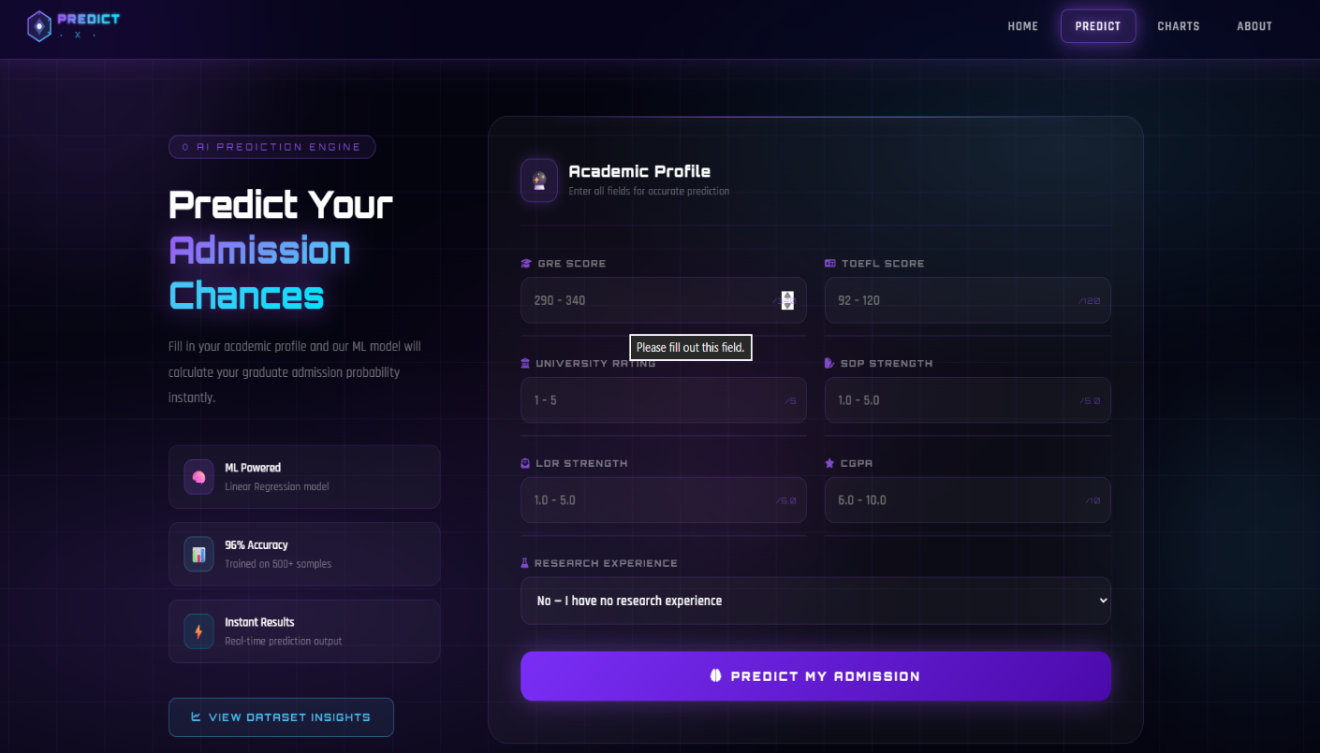
<!DOCTYPE html>
<html lang="en">
<head>
<meta charset="UTF-8"/>
<meta name="viewport" content="width=device-width, initial-scale=1.0"/>
<title>PredictX — Predict Admission</title>
<link href="https://fonts.googleapis.com/css2?family=Orbitron:wght@400;600;900&family=Rajdhani:wght@300;400;600&display=swap" rel="stylesheet"/>
<link rel="stylesheet" href="https://cdnjs.cloudflare.com/ajax/libs/font-awesome/6.4.0/css/all.min.css"/>
<style>
:root {
--neon-purple: #9b59f5;
--neon-blue: #4fc3f7;
--neon-cyan: #00e5ff;
--neon-pink: #e040fb;
--bg-dark: #04040f;
--glow-purple: 0 0 20px rgba(155,89,245,0.5), 0 0 60px rgba(155,89,245,0.2);
--glow-blue: 0 0 20px rgba(79,195,247,0.5), 0 0 60px rgba(79,195,247,0.2);
}
* { margin: 0; padding: 0; box-sizing: border-box; }
body { font-family: 'Rajdhani', sans-serif; background: var(--bg-dark); color: white; min-height: 100vh; overflow-x: hidden; }

.bg-canvas { position: fixed; inset: 0; z-index: 0;
background: radial-gradient(ellipse 80% 60% at 20% 80%, rgba(155,89,245,0.18) 0%, transparent 60%),
radial-gradient(ellipse 60% 50% at 80% 20%, rgba(79,195,247,0.12) 0%, transparent 60%),
radial-gradient(ellipse 40% 40% at 50% 50%, rgba(224,64,251,0.06) 0%, transparent 70%), #04040f; }
.bg-grid { position: fixed; inset: 0; z-index: 0;
background-image: linear-gradient(rgba(155,89,245,0.07) 1px, transparent 1px), linear-gradient(90deg, rgba(155,89,245,0.07) 1px, transparent 1px);
background-size: 60px 60px; animation: gridMove 20s linear infinite; }
@keyframes gridMove { 0% { background-position: 0 0; } 100% { background-position: 60px 60px; } }
.orb { position: fixed; border-radius: 50%; filter: blur(80px); z-index: 0; pointer-events: none; animation: orbFloat 8s ease-in-out infinite; }
.orb-1 { width:400px; height:400px; background:rgba(155,89,245,0.15); top:-100px; left:-100px; }
.orb-2 { width:300px; height:300px; background:rgba(79,195,247,0.12); bottom:100px; right:-80px; animation-delay:-3s; }
.orb-3 { width:200px; height:200px; background:rgba(224,64,251,0.1); top:50%; left:50%; animation-delay:-6s; }
@keyframes orbFloat { 0%,100% { transform:translate(0,0) scale(1); } 33% { transform:translate(30px,-40px) scale(1.05); } 66% { transform:translate(-20px,20px) scale(0.95); } }

/* NAVBAR */
.navbar { position: fixed; top:0; left:0; right:0; z-index:100;
display: flex; align-items:center; justify-content:space-between;
padding: 0 50px; height: 70px; background: rgba(10,5,30,0.55);
backdrop-filter: blur(20px) saturate(180%); -webkit-backdrop-filter: blur(20px) saturate(180%);
border-bottom: 1px solid rgba(155,89,245,0.3);
box-shadow: 0 4px 30px rgba(155,89,245,0.15), inset 0 1px 0 rgba(255,255,255,0.06); }
.nav-links { display:flex; gap:8px; align-items:center; }
.nav-links a { color: rgba(255,255,255,0.7); text-decoration: none; font-size:14px; font-weight:600;
letter-spacing:1.5px; text-transform:uppercase; padding: 8px 18px; border-radius:8px;
border: 1px solid transparent; transition: all 0.3s ease; }
.nav-links a:hover { color: white; background:rgba(155,89,245,0.15); border-color:rgba(155,89,245,0.4); box-shadow:0 0 15px rgba(155,89,245,0.3); text-shadow:0 0 8px rgba(155,89,245,0.8); }
.nav-links a.active { color: white; background:rgba(155,89,245,0.2); border-color:rgba(155,89,245,0.5); box-shadow: var(--glow-purple); text-shadow:0 0 10px var(--neon-purple); }

/* MAIN */
.main { position: relative; z-index:10; padding-top: 70px; min-height: 100vh; display: flex; align-items: center; justify-content: center; padding-bottom: 60px; }
.wrapper { width: 100%; max-width: 1300px; display: flex; gap: 60px; padding: 60px 40px 40px; align-items: flex-start; animation: fadeUp 0.8s ease both; }
@keyframes fadeUp { from { opacity:0; transform:translateY(30px); } to { opacity:1; transform:translateY(0); } }

/* LEFT PANEL */
.left-panel { flex: 0 0 340px; padding-top: 20px; }
.page-tag { display: inline-block; font-family: 'Orbitron', monospace; font-size: 10px; letter-spacing:4px; color: var(--neon-purple); border: 1px solid rgba(155,89,245,0.4); padding: 5px 16px; border-radius:20px; background: rgba(155,89,245,0.08); margin-bottom: 24px; }
.left-panel h1 { font-family: 'Orbitron', monospace; font-size: clamp(26px, 3vw, 40px); font-weight: 900; line-height: 1.2; margin-bottom: 18px; }
.left-panel h1 span { background: linear-gradient(135deg, var(--neon-purple), var(--neon-blue), var(--neon-cyan)); -webkit-background-clip: text; -webkit-text-fill-color: transparent; background-clip: text; filter: drop-shadow(0 0 15px rgba(155,89,245,0.6)); }
.left-panel p { font-size: 15px; color: rgba(255,255,255,0.45); line-height: 1.8; margin-bottom: 36px; letter-spacing: 0.3px; }

.info-cards { display:flex; flex-direction:column; gap:14px; margin-bottom:36px; }
.info-card { display: flex; align-items:center; gap:14px; background: rgba(255,255,255,0.03); border: 1px solid rgba(155,89,245,0.15); border-radius: 12px; padding: 14px 18px; transition: all 0.3s; }
.info-card:hover { border-color: rgba(155,89,245,0.35); background: rgba(155,89,245,0.07); }
.info-icon { width:38px; height:38px; border-radius:10px; display:flex; align-items:center; justify-content:center; font-size:16px; flex-shrink:0; }
.ic-purple { background:rgba(155,89,245,0.15); border:1px solid rgba(155,89,245,0.3); }
.ic-blue { background:rgba(79,195,247,0.1); border:1px solid rgba(79,195,247,0.3); }
.ic-cyan { background:rgba(0,229,255,0.08); border:1px solid rgba(0,229,255,0.25); }
.info-card-text strong { display:block; font-size:14px; font-weight:600; margin-bottom:2px; color:white; }
.info-card-text span { color:rgba(255,255,255,0.4); font-size:12px; letter-spacing:0.5px; }

.chart-btn { display: inline-flex; align-items:center; gap:8px; padding: 13px 28px; border-radius:10px; border: 1px solid rgba(79,195,247,0.4); background: rgba(79,195,247,0.08); color: var(--neon-blue); font-family: 'Orbitron', monospace; font-size:11px; font-weight:600; letter-spacing:2px; cursor:pointer; text-decoration:none; transition:all 0.3s; }
.chart-btn:hover { background:rgba(79,195,247,0.18); box-shadow: var(--glow-blue); transform: translateY(-2px); }

/* FORM CARD */
.form-card { flex: 1; background: rgba(255,255,255,0.03); backdrop-filter: blur(20px); -webkit-backdrop-filter: blur(20px); border: 1px solid rgba(155,89,245,0.2); border-radius: 24px; padding: 44px 40px; position: relative; overflow:hidden; }
.form-card::before { content:''; position:absolute; top:0; left:10%; right:10%; height:1px; background: linear-gradient(90deg, transparent, rgba(155,89,245,0.7), rgba(79,195,247,0.5), transparent); box-shadow: 0 0 12px rgba(155,89,245,0.4); }
.form-header { display:flex; align-items:center; gap:14px; margin-bottom: 34px; padding-bottom: 24px; border-bottom: 1px solid rgba(155,89,245,0.12); }
.form-header-icon { width:46px; height:46px; border-radius:12px; background:rgba(155,89,245,0.15); border:1px solid rgba(155,89,245,0.35); display:flex; align-items:center; justify-content:center; font-size:20px; box-shadow: 0 0 15px rgba(155,89,245,0.25); }
.form-header-text h2 { font-family:'Orbitron', monospace; font-size:17px; font-weight:700; letter-spacing:1px; margin-bottom:3px; }
.form-header-text p { font-size:12px; color:rgba(255,255,255,0.35); letter-spacing:0.5px; }

.form-grid { display: grid; grid-template-columns: 1fr 1fr; gap: 22px; }
.full { grid-column: 1 / 3; }
.field { display:flex; flex-direction:column; gap:8px; }
.field label { font-family: 'Orbitron', monospace; font-size: 10px; font-weight:600; letter-spacing: 2px; text-transform:uppercase; color: rgba(255,255,255,0.45); display:flex; align-items:center; gap:6px; }
.field label i { font-size:11px; color:var(--neon-purple); opacity:0.8; }
.input-wrap { position:relative; border-radius:12px; background:rgba(255,255,255,0.03); border:1px solid rgba(155,89,245,0.18); transition: all 0.3s; }
.input-wrap:focus-within { border-color: rgba(155,89,245,0.6); box-shadow: 0 0 0 3px rgba(155,89,245,0.1), 0 0 20px rgba(155,89,245,0.15); background: rgba(155,89,245,0.04); }
.input-wrap input, .input-wrap select { width:100%; padding:14px 16px; background:transparent; border:none; outline:none; color:white; font-family:'Rajdhani',sans-serif; font-size:15px; font-weight:600; letter-spacing:0.5px; border-radius:12px; }
.input-wrap select option { background:#0d0920; color:white; }
.hint-tag { position:absolute; right:12px; top:50%; transform:translateY(-50%); font-family:'Orbitron',monospace; font-size:9px; letter-spacing:1px; color:rgba(155,89,245,0.5); pointer-events:none; }
.range-bar { height:2px; border-radius:2px; background:rgba(155,89,245,0.12); margin-top:4px; overflow:hidden; }
.range-fill { height:100%; background:linear-gradient(90deg, var(--neon-purple), var(--neon-blue)); border-radius:2px; width:0%; transition: width 0.4s ease; }

.submit-btn { margin-top:28px; width:100%; padding: 18px; border:none; border-radius:14px; background: linear-gradient(135deg, #7b2ff7, #4b0aab); color:white; font-family:'Orbitron',monospace; font-size:13px; font-weight:700; letter-spacing:3px; cursor:pointer; transition:all 0.3s; position:relative; overflow:hidden; box-shadow: 0 0 30px rgba(155,89,245,0.4); }
.submit-btn::before { content:''; position:absolute; inset:0; background:linear-gradient(135deg, rgba(155,89,245,0.3), rgba(79,195,247,0.2)); opacity:0; transition:opacity 0.3s; }
.submit-btn:hover { transform:translateY(-3px); box-shadow:0 0 50px rgba(155,89,245,0.6), 0 12px 30px rgba(155,89,245,0.3); }
.submit-btn:hover::before { opacity:1; }
.submit-btn span { position:relative; z-index:1; display:flex; align-items:center; justify-content:center; gap:10px; }

/* ── RESULT BOX ── */
.result { margin-top:24px; padding: 28px 30px; border-radius:16px; background: rgba(255,255,255,0.03); border: 1px solid rgba(155,89,245,0.35); position:relative; overflow:hidden; animation: resultIn 0.5s ease both; }
@keyframes resultIn { from { opacity:0; transform:scale(0.96); } to { opacity:1; transform:scale(1); } }
.result::before { content:''; position:absolute; top:0; left:0; right:0; height:1px; background: linear-gradient(90deg, transparent, var(--neon-purple), var(--neon-blue), transparent); }
.result-inner { display:flex; align-items:center; gap:24px; flex-wrap:wrap; }
.result-circle { width:90px; height:90px; border-radius:50%; flex-shrink:0; border:2px solid rgba(155,89,245,0.5); background:rgba(155,89,245,0.08); display:flex; flex-direction:column; align-items:center; justify-content:center; box-shadow: 0 0 25px rgba(155,89,245,0.25); }
.result-pct { font-family:'Orbitron',monospace; font-size:22px; font-weight:900; background:linear-gradient(135deg, var(--neon-purple), var(--neon-blue)); -webkit-background-clip:text; -webkit-text-fill-color:transparent; background-clip:text; line-height:1; }
.result-pct-label { font-size:10px; color:rgba(255,255,255,0.35); letter-spacing:1px; margin-top:3px; }
.result-info { flex:1; }

/* 3 result tag styles */
.result-tag { display:inline-block; font-family:'Orbitron',monospace; font-size:9px; letter-spacing:2px; padding:4px 12px; border-radius:4px; margin-bottom:8px; text-transform:uppercase; }
.tag-admit { background:rgba(0,229,129,0.12); color:#00e581; border:1px solid rgba(0,229,129,0.3); }
.tag-moderate { background:rgba(255,180,0,0.12); color:#ffb400; border:1px solid rgba(255,180,0,0.35); }
.tag-reject { background:rgba(255,65,65,0.12); color:#ff4141; border:1px solid rgba(255,65,65,0.3); }

.result-status { font-family:'Orbitron',monospace; font-size:18px; font-weight:700; margin-bottom:4px; letter-spacing:1px; }
.result-sub { font-size:13px; color:rgba(255,255,255,0.4); }
.result-bar { margin-top:16px; height:4px; border-radius:4px; background:rgba(255,255,255,0.06); overflow:hidden; }
.result-bar-fill { height:100%; border-radius:4px; background:linear-gradient(90deg, var(--neon-purple), var(--neon-cyan)); box-shadow:0 0 8px rgba(155,89,245,0.5); transition:width 1s ease; width:0; }

@media (max-width:1000px) { .wrapper { flex-direction:column; gap:30px; padding:90px 20px 40px; } .left-panel { flex:none; width:100%; padding-top:0; } }
@media (max-width:640px) { .navbar { padding:0 20px; } .nav-links { display:none; } .form-grid { grid-template-columns:1fr; } .full { grid-column:1; } .form-card { padding:28px 20px; } }
</style>
</head>
<body>

<div class="bg-canvas"></div>
<div class="bg-grid"></div>
<div class="orb orb-1"></div>
<div class="orb orb-2"></div>
<div class="orb orb-3"></div>

<nav class="navbar">
<a href="/" style="text-decoration:none;display:flex;align-items:center;">
<svg width="160" height="38" viewBox="0 0 160 38" fill="none" xmlns="http://www.w3.org/2000/svg">
<defs>
<linearGradient id="hexGrad" x1="0" y1="0" x2="1" y2="1"><stop offset="0%" stop-color="#9b59f5"/><stop offset="100%" stop-color="#4fc3f7"/></linearGradient>
<linearGradient id="textGrad" x1="0" y1="0" x2="1" y2="0"><stop offset="0%" stop-color="#9b59f5"/><stop offset="60%" stop-color="#4fc3f7"/><stop offset="100%" stop-color="#00e5ff"/></linearGradient>
<filter id="glow"><feGaussianBlur stdDeviation="1.5" result="blur"/><feMerge><feMergeNode in="blur"/><feMergeNode in="SourceGraphic"/></feMerge></filter>
</defs>
<polygon points="19,3 33,11 33,27 19,35 5,27 5,11" fill="url(#hexGrad)" opacity="0.15" filter="url(#glow)"/>
<polygon points="19,3 33,11 33,27 19,35 5,27 5,11" fill="none" stroke="url(#hexGrad)" stroke-width="1.5"/>
<polygon points="19,10 26,19 19,28 12,19" fill="url(#hexGrad)" opacity="0.5"/>
<circle cx="19" cy="19" r="3" fill="white" opacity="0.9"/>
<line x1="19" y1="3" x2="19" y2="7" stroke="#9b59f5" stroke-width="1.2" opacity="0.8"/>
<line x1="33" y1="11" x2="29.5" y2="13" stroke="#4fc3f7" stroke-width="1.2" opacity="0.8"/>
<line x1="33" y1="27" x2="29.5" y2="25" stroke="#4fc3f7" stroke-width="1.2" opacity="0.8"/>
<text x="42" y="16" font-family="'Orbitron', monospace" font-size="13" font-weight="900" fill="url(#textGrad)" letter-spacing="2" filter="url(#glow)">PREDICT</text>
<text x="44" y="31" font-family="'Orbitron', monospace" font-size="9" font-weight="400" fill="#4fc3f7" letter-spacing="6" opacity="0.8">· X ·</text>
<line x1="42" y1="19" x2="152" y2="19" stroke="url(#textGrad)" stroke-width="0.5" opacity="0.4"/>
</svg>
</a>
<div class="nav-links">
<a href="/">Home</a>
<a href="/predict_page" class="active">Predict</a>
<a href="/charts">Charts</a>
<a href="/about">About</a>
</div>
</nav>

<div class="main">
<div class="wrapper">

<!-- LEFT PANEL -->
<div class="left-panel">
<div class="page-tag">⬡ AI PREDICTION ENGINE</div>
<h1>Predict Your<br><span>Admission Chances</span></h1>
<p>Fill in your academic profile and our ML model will calculate your graduate admission probability instantly.</p>
<div class="info-cards">
<div class="info-card">
<div class="info-icon ic-purple">🧠</div>
<div class="info-card-text"><strong>ML Powered</strong><span>Linear Regression model</span></div>
</div>
<div class="info-card">
<div class="info-icon ic-blue">📊</div>
<div class="info-card-text"><strong>96% Accuracy</strong><span>Trained on 500 samples</span></div>
</div>
<div class="info-card">
<div class="info-icon ic-cyan">⚡</div>
<div class="info-card-text"><strong>Instant Results</strong><span>Real-time prediction output</span></div>
</div>
</div>
<a href="/charts" class="chart-btn"><i class="fa-solid fa-chart-line"></i> VIEW DATASET INSIGHTS</a>
</div>

<!-- FORM CARD -->
<div class="form-card">
<div class="form-header">
<div class="form-header-icon">🔮</div>
<div class="form-header-text">
<h2>Academic Profile</h2>
<p>Enter all fields for accurate prediction</p>
</div>
</div>

<form action="/predict" method="POST">
<div class="form-grid">

<div class="field">
<label><i class="fa-solid fa-graduation-cap"></i> GRE Score</label>
<div class="input-wrap">
<input type="number" name="gre" placeholder="290 – 340" min="260" max="340" required oninput="updateBar(this,'gre-bar',260,340)"/>
<span class="hint-tag">/340</span>
</div>
<div class="range-bar"><div class="range-fill" id="gre-bar"></div></div>
</div>

<div class="field">
<label><i class="fa-solid fa-language"></i> TOEFL Score</label>
<div class="input-wrap">
<input type="number" name="toefl" placeholder="92 – 120" min="0" max="120" required oninput="updateBar(this,'toefl-bar',0,120)"/>
<span class="hint-tag">/120</span>
</div>
<div class="range-bar"><div class="range-fill" id="toefl-bar"></div></div>
</div>

<div class="field">
<label><i class="fa-solid fa-university"></i> University Rating</label>
<div class="input-wrap">
<input type="number" name="rating" placeholder="1 – 5" min="1" max="5" required oninput="updateBar(this,'rating-bar',1,5)"/>
<span class="hint-tag">/5</span>
</div>
<div class="range-bar"><div class="range-fill" id="rating-bar"></div></div>
</div>

<div class="field">
<label><i class="fa-solid fa-file-pen"></i> SOP Strength</label>
<div class="input-wrap">
<input type="number" name="sop" placeholder="1.0 – 5.0" step="0.5" min="1" max="5" required oninput="updateBar(this,'sop-bar',1,5)"/>
<span class="hint-tag">/5.0</span>
</div>
<div class="range-bar"><div class="range-fill" id="sop-bar"></div></div>
</div>

<div class="field">
<label><i class="fa-solid fa-envelope-open-text"></i> LOR Strength</label>
<div class="input-wrap">
<input type="number" name="lor" placeholder="1.0 – 5.0" step="0.5" min="1" max="5" required oninput="updateBar(this,'lor-bar',1,5)"/>
<span class="hint-tag">/5.0</span>
</div>
<div class="range-bar"><div class="range-fill" id="lor-bar"></div></div>
</div>

<div class="field">
<label><i class="fa-solid fa-star"></i> CGPA</label>
<div class="input-wrap">
<input type="number" name="cgpa" placeholder="6.0 – 10.0" step="0.01" min="0" max="10" required oninput="updateBar(this,'cgpa-bar',0,10)"/>
<span class="hint-tag">/10</span>
</div>
<div class="range-bar"><div class="range-fill" id="cgpa-bar"></div></div>
</div>

<div class="field full">
<label><i class="fa-solid fa-flask"></i> Research Experience</label>
<div class="input-wrap">
<select name="research">
<option value="0">No — I have no research experience</option>
<option value="1">Yes — I have research experience</option>
</select>
</div>
</div>

</div>

<button type="submit" class="submit-btn">
<span><i class="fa-solid fa-brain"></i> PREDICT MY ADMISSION</span>
</button>
</form>

<!-- RESULT — 3 CONDITIONS -->
{% if prediction %}
<div class="result">
<div class="result-inner">
<div class="result-circle">
<div class="result-pct">{{ prediction }}%</div>
<div class="result-pct-label">CHANCE</div>
</div>
<div class="result-info">

{% if prediction|int >= 80 %}
<div class="result-tag tag-admit">✓ HIGH CHANCE</div>
{% elif prediction|int >= 50 %}
<div class="result-tag tag-moderate">⚖ MODERATE CHANCE</div>
{% else %}
<div class="result-tag tag-reject">✗ LOW CHANCE</div>
{% endif %}

<div class="result-status">{{ status }}</div>
<div class="result-sub">Based on your academic profile analysis</div>
<div class="result-bar">
<div class="result-bar-fill" id="result-fill" data-pct="{{ prediction }}"></div>
</div>

</div>
</div>
</div>
{% endif %}

</div>
</div>
</div>

<script>
function updateBar(input, barId, min, max) {
const bar = document.getElementById(barId);
if (!bar) return;
const val = parseFloat(input.value);
if (isNaN(val)) { bar.style.width = '0%'; return; }
bar.style.width = Math.min(100, Math.max(0, ((val - min) / (max - min)) * 100)) + '%';
}

window.addEventListener('DOMContentLoaded', function() {
const fill = document.getElementById('result-fill');
if (fill) {
const pct = parseFloat(fill.getAttribute('data-pct'));
if (!isNaN(pct)) setTimeout(() => { fill.style.width = Math.min(100, Math.max(0, pct)) + '%'; }, 100);
}
});
</script>

</body>
</html>

RESULT
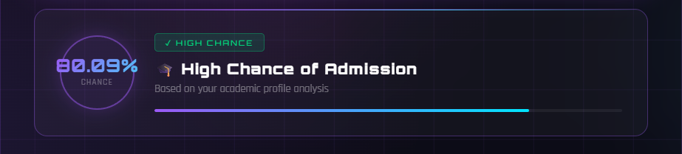

CHARTS

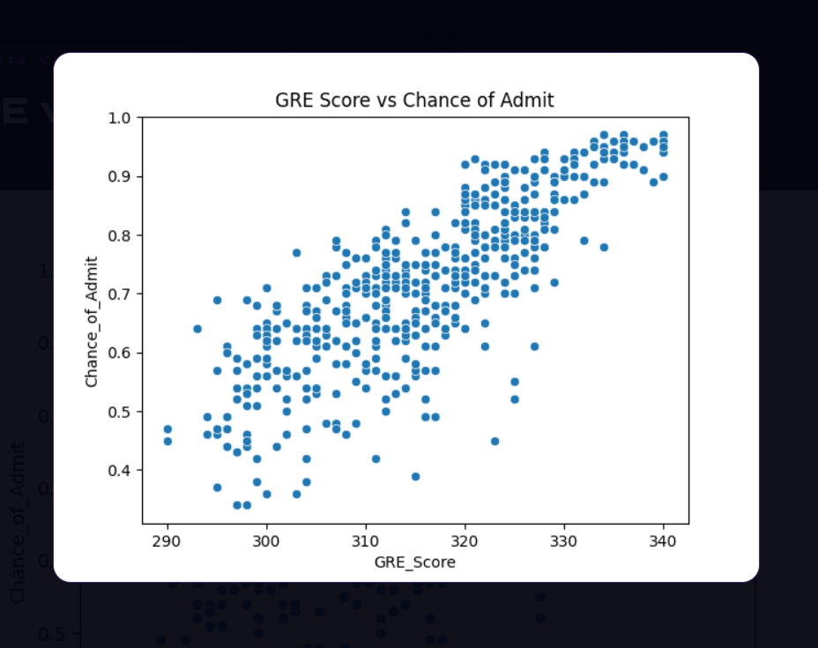

GRE Score vs Chance of Admit (Scatter Plot)

The scatter plot of GRE Score against Chance of Admission reveals a strong, clear positive linear relationship. Applicants scoring around 290 on the GRE tend to have admission chances in the range of 0.35 to 0.50, while those scoring near 340 — the maximum — see their chances rise to 0.85–0.97. The upward trend is consistent and tight across the score range, with relatively few outliers. This is fully consistent with the 0.81 correlation observed in the heatmap. It also shows that GRE score alone can be a strong signal of admission likelihood. However, there is still visible spread at each GRE score level, meaning other factors like CGPA, TOEFL, and research experience also contribute independently to the final admission probability.

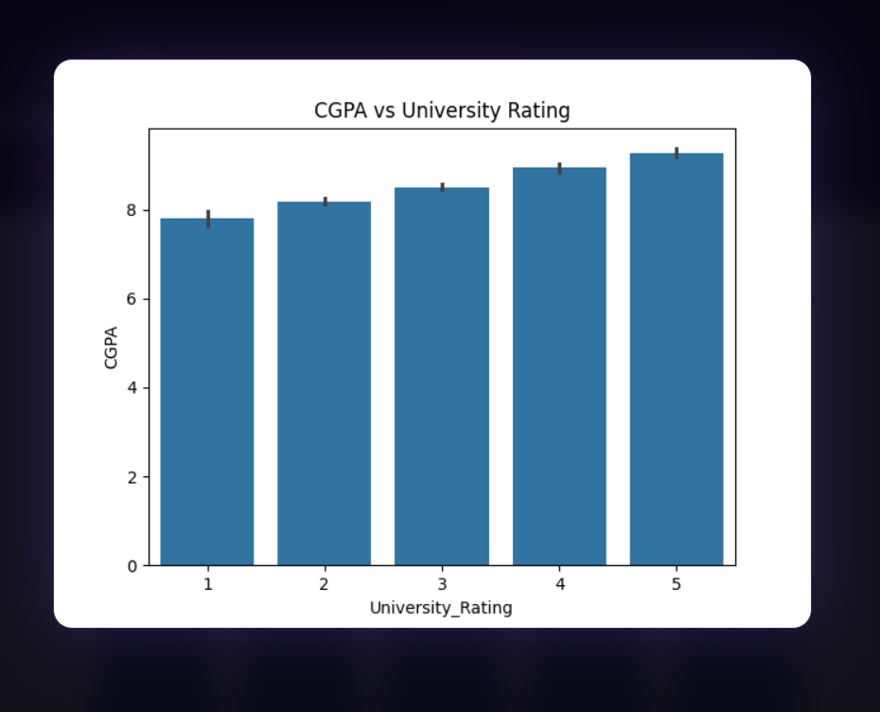

CGPA vs University Rating (Bar Chart)

This bar chart shows a steady and consistent increase in average CGPA as the university rating goes up. Applicants from Rating 1 universities average around 7.8 CGPA, while those from Rating 5 universities average approximately 9.1 CGPA. This monotonic increase confirms a strong alignment between academic performance and institutional prestige. In other words, students with higher GPAs tend to target and gain admission to better-rated universities. This also reinforces the heatmap finding that CGPA and University Rating are moderately correlated (0.71). The error bars in the chart are very small, especially at Rating 4 and 5, suggesting that the higher-rated groups are more academically homogeneous and consistently high
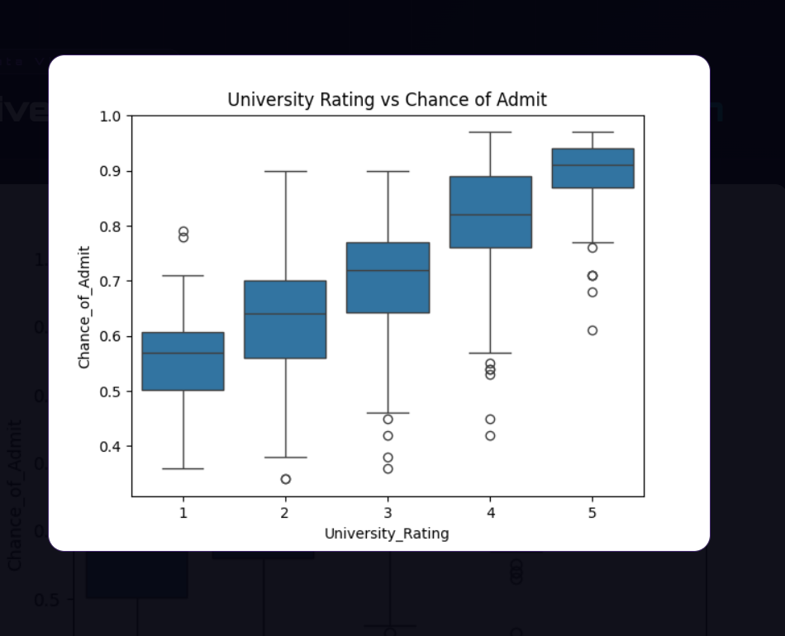

University Rating vs Chance of Admit (Box Plot)

This box plot clearly shows that as the university rating increases from 1 to 5, the median admission chance rises consistently and significantly. Rating 1 applicants have a median admission chance of roughly 0.55–0.60, with considerable spread downward to around 0.35. Rating 5 applicants cluster tightly around 0.90 to 0.93, with very little downward variation. This tells us two important things. First, students applying to higher-rated universities tend to be stronger overall candidates. Second, higher university ratings are themselves associated with better admission outcomes, possibly because students from prestigious institutions are better prepared or more competitive. The interquartile range also narrows as ratings increase, meaning top-tier applicants are more consistently strong, while lower-rated applicants show more variability in their outcomes.

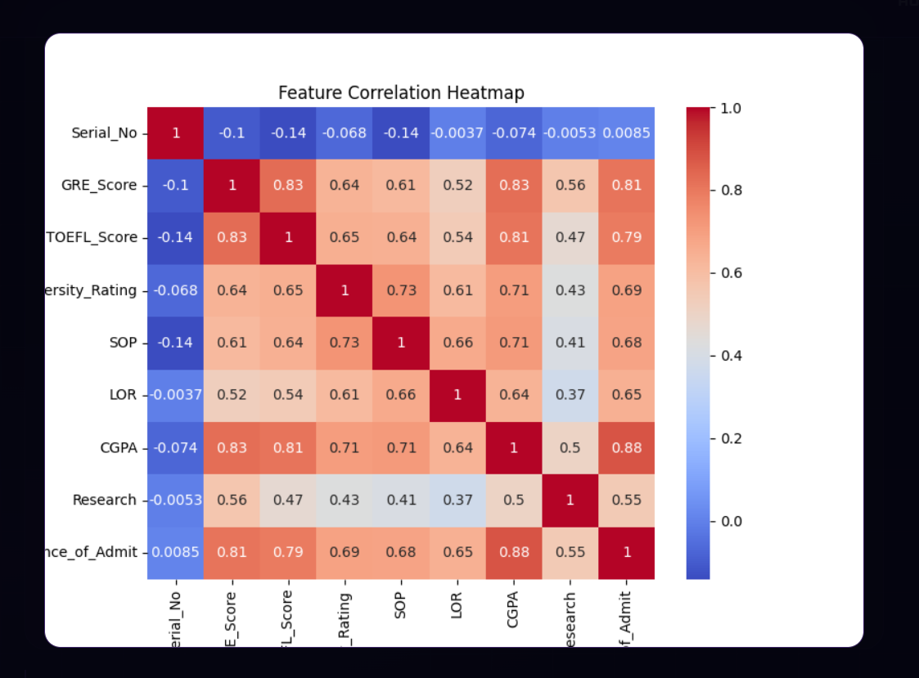

Feature Correlation (Heatmap)

The heatmap reveals how strongly each feature is related to the Chance of Admission and to each other. The key findings are as follows:
CGPA has the strongest correlation with admission at 0.88, making it the single most important predictor. GRE Score follows closely at 0.81, and TOEFL Score at 0.79, showing that standardized test performance is a major factor. University Rating (0.69) and SOP (0.68) are moderate predictors, indicating that the quality of the institution and the strength of the personal statement also play a meaningful role. LOR (0.65) has a slightly lower but still notable correlation. Research (0.55) provides a meaningful boost. Serial Number, as expected, has near-zero correlation since it is just an identifier with no predictive value.
An important additional observation is that CGPA, GRE, and TOEFL are also highly correlated with each other — for example, GRE and CGPA share a 0.83 correlation. This means that strong students tend to perform well across all academic metrics simultaneously, and weakness in one area is rarely isolated.
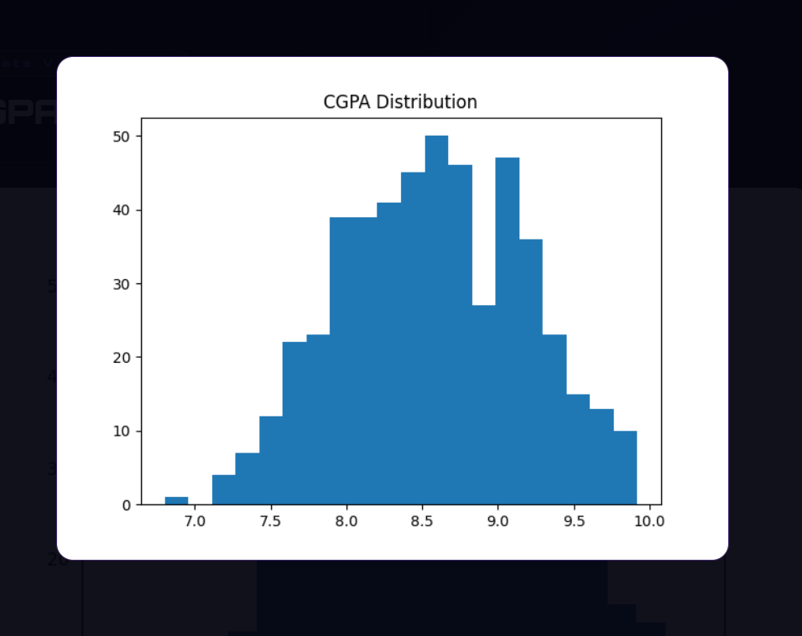

CGPA Distribution (Histogram)

The CGPA distribution shows that most applicants fall between 8.0 and 9.2, with the highest concentration peaking around 8.5 to 8.7. The distribution is roughly bell-shaped but slightly right-skewed, meaning there are more applicants on the higher end than the lower end. Very few students fall below 7.0, indicating this is a highly competitive and academically strong applicant pool. The narrow spread around 8.5 also means that even small differences in CGPA — for example, 8.4 vs 8.9 — can significantly impact admission chances, given that CGPA has the highest correlation (0.88) with the target variable.

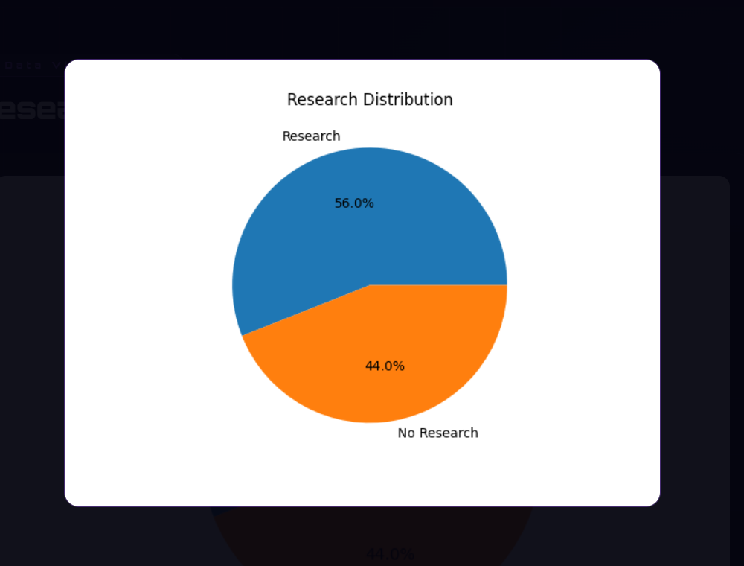

Research Distribution (Pie Chart)

Out of 500 applicants, 56% have research experience and 44% do not. This is a fairly balanced split, meaning research experience is common but not universal in this applicant pool. This matters because research has a 0.55 correlation with admission chances, making it a meaningful differentiator. Applicants with research experience generally have a higher probability of admission compared to those without. The near-equal split also suggests that many strong applicants are admitted even without research, meaning other factors like CGPA and GRE scores can compensate.

CONCLUSION

- The Graduate Admission Prediction System successfully analyzes academic data and predicts admission probability.

- The system helps students understand their chances of admission and provides insights using data visualization and machine learning.

FUTURE SCOPE

- Use larger datasets
- Add more machine learning models

- Improve prediction accuracy

- Integrate real university admission data

- Develop mobile application

REFERENCES

- Kaggle Dataset
- Python Documentation
- Scikit-learn Documentation
- Research articles on admission prediction

Example :
- https://www.kaggle.com
- https/scikit-learn.org
- https:/pandas.pydata.org

